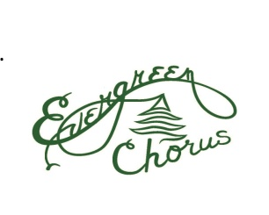 HOLIDAY HARMONY 2019 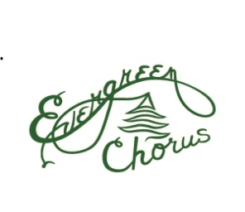 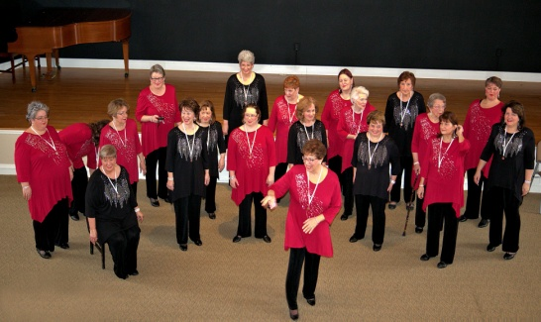
EVERGREEN CHORUS
It’s the most wonderful time of the year
to sing with Evergreen Chorus Holiday Harmony Performance
No auditions required! No Cost!
Vocal Instruction given at each rehearsal
Rehearsals: Tuesdays, 11/5, 11/12, 11/19, 11/26,12/3
Evergreen rehearsal hall: Crown Heights Clubhouse
34 Nassau Road
Poughkeepsie, NY 12601
Performance: Sunday, December 8, 2019
7:00 PM
RSVP or more details: email Mary at: dougandmary74@gmail.com or call: 845-728-3549

Find us on Facebook, Instagram, or see our website: www.evergreenchorus.org
-----------------------------------------------------------------------------------------------------------------------------
*Chapter of Sweet Adelines International * *Member of Dutchess County Chamber of Commerce*

